Harpley War Memorial is One Hundred Years Old.
In November 1920 shortly after the Cenotaph was unveiled in Whitehall, Harpley had its own ceremony as the new War Memorial was dedicated by the Bishop of Thetford after a service in St Lawrence’s Church on 20th November 1920.
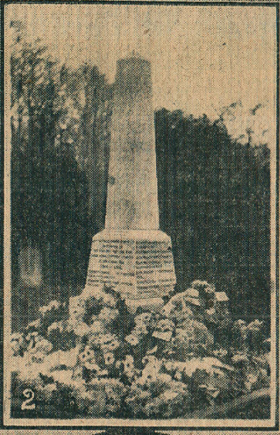
The Eastern Daily Press report on Tues, 23rd November showed this picture and included details of similar events at St Michael’s Church, Aylsham, at Mundford and at Dunston.
The memorial is an obelisk of white marble on a plinth and was designed by Mr Holman of King’s Lynn. It was paid for by the then residents of Harpley.
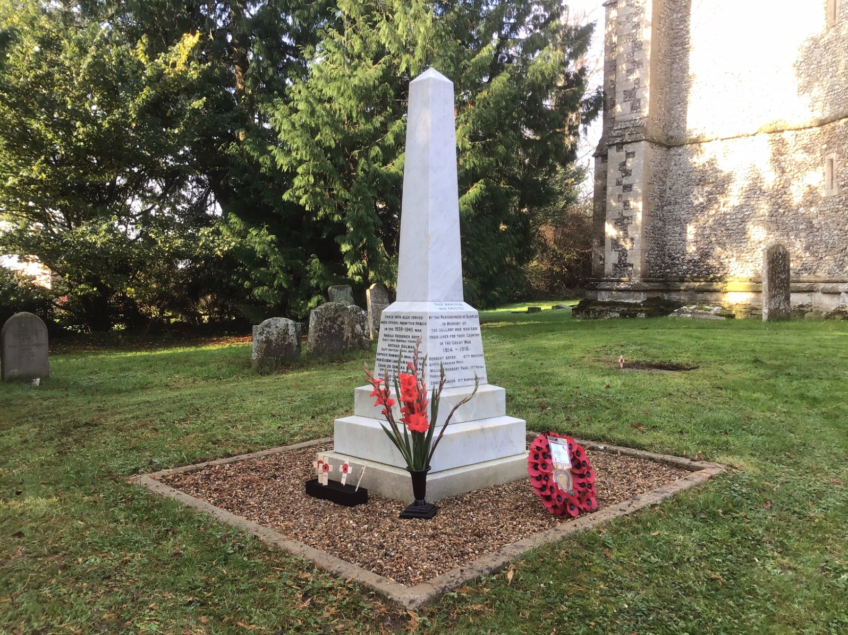
Similarly, in 2017, local residents again made donations towards the cost of cleaning and repairing the lead lettering. The War Memorials Trust also made a generous grant towards the cost of the work.

It has proved to be impossible to hold a memorial service to mark exactly 100 years since the memorial was dedicated but a service was held on Remembrance Sunday, 8th November 2020 when a small number of Harpley residents gathered round the memorial for an Act of Remembrance. Those attending were masked and able to keep well distanced; the sun shone. As many other churches were unable to hold Remembrance Services due to COVID-19 restrictions this year we felt very much that we were representing all of them as well during this short service. The wreath was provided by Fakenham Branch of the Royal British Legion. Mr Alexis Brun played The Last Post and Reveille to define the two minutes silence.

Below: the Reverend Judith Pollard conducts the service at Harpley’s War Memorial.
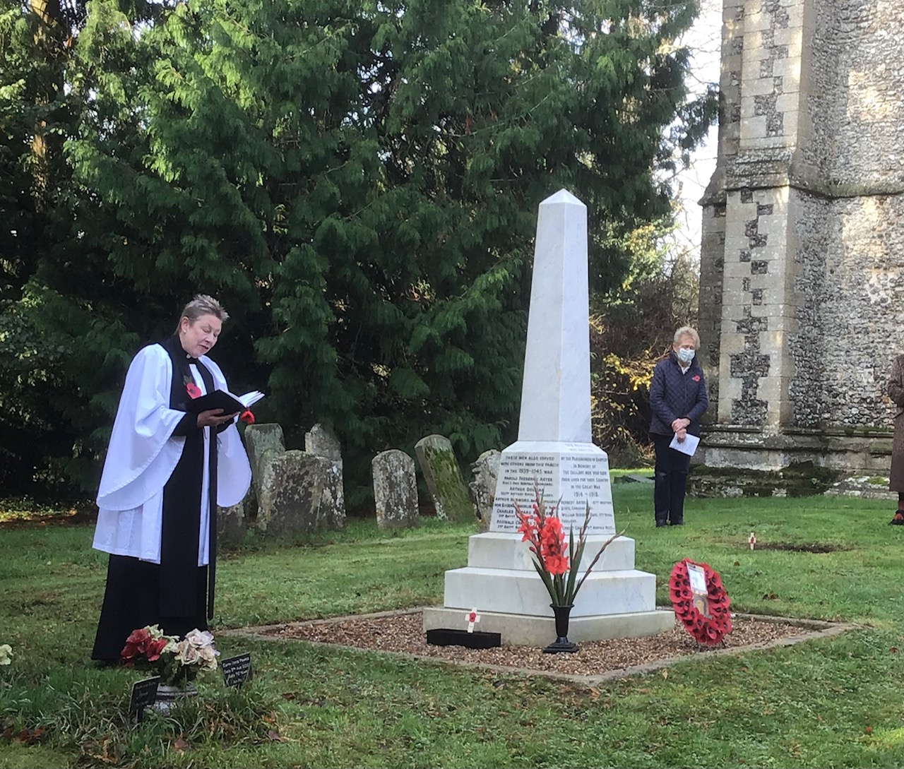
8th November 2020

