Notes from around the Parishes, December 2019

Harpley & the Massinghams

**Stir up the wills of your faithful people...**

For the first time in years my husband suggested that we do some Christmas baking, make a fruit cake and perhaps a plum pudding or two. After all, as I write, next week it’s Stir up Sunday!

Traditionally, Stir Up Sunday is the last Sunday before Advent (a penitential season) and like Shrove Tuesday before Lent it was customary to use up rich ingredients beforehand. Also, the special prayer for that Sunday began with the words: “*Stir up we beseech thee O Lord, the wills of Thy faithful people..”.* Of course, folk made up their own version: Stir up, we beseech thee the pudding in the pot...and keep it hot! Tradition has it that making Christmas fare on Stir Up Sunday brings good luck – and it gives the food time to mature and develop flavour all ready for Christmas.

At this time of the year we have a Children’s Workshop at Harpley Church ~ Birthday Cakes for Jesus! We stir up all the ingredients, bake them (not in church!) and later, at a second workshop, we ice the cakes creatively in time for Christmas. We all have a lot of fun doing this, children and adults alike.

It’s good to think of safe and predictable things in the run-up to Christmas 2019 – carol services, present-buying, decorating the tree - to counterbalance the uncertainty in our United Kingdom at this time. As we still experience the political contortions of Brexit and approach a December General Election for the first time since 1923, even if we look beyond our shores to the wider world, all we see is unrest and division. There is no peace, no goodwill. We are challenged on all sides, particularly in the way we abuse our planet and its resources. Members of my own wider family have been active in the climate change protests in London, fervently believing that we all have a stake in the quality of life of future generations – and we must do something positive now before it’s too late.

The annual reassertion of our Christian faith at Christmas through the birth of Jesus, the Christ-child, comes at an important time. Every year this Christian festival, this celebration of love, vulnerability and sheer humanity, reminds us that in all this earthly turmoil we are not alone. God loves us so much that he sent his Son to be with us to experience our human predicament in all its gritty reality - even to death on a cross. The story of our redemption begins at Christmas.

Never have we needed more the message of the angels:   
 *Peace on earth, goodwill to all people*.   
As Charles Dickens’ Tiny Tim observed “God bless us, every one!”   
 Happy Christmas to you all, **Reverend Judith**

SERVICES ACROSS THE GROUP in December

**Sunday, December 1st ~** *Advent Sunday*

**0830 Holy Communion** All Saints’, Roydon **0930 Morning Prayer (Lay led)** Saint Andrew’s, Little Mass **\*0930* Family Service (Lay led)** St Lawrence’s**, Harpley**  
**1100** Family Communion St Mary’s, **Great Mass**0830Holy Communion All Saints’, Ashwicken  
1030Holy Communion St Botolph’s, Grimston  
**1030** Morning Praise St Nicholas’, Gayton **3pm Prayer Meeting The Rectory, Gayton**

**\* Note change of time for Harpley Service above \***

**Weds, Dec 4th ~** 9am Holy Communion **at St Lawrence’s, Harpley**

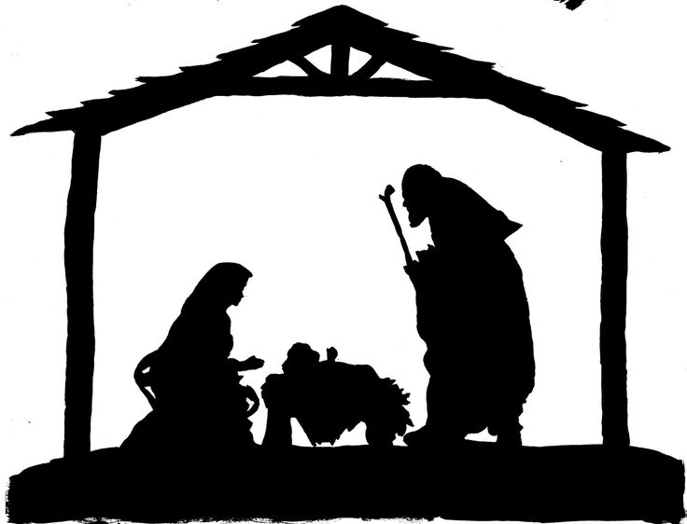

Saturday, Dec 7**th at 3pm**

**Carols in the Stable**

Cliffe en Howe Road, Pott Row

**Sunday, December 8th**  *Advent 2***1030**Group Holy Communion St Botolph’s, Grimston



Carol Services around the Group in December

**15th at 3pm** (?) St Andrew’s, Little Massingham

**13th at 7pm** All Saints’, Ashwicken

**15th at 3pm** St Nicholas’, Gayton

**15th at 6pm** All Saints’, Roydon

**17th at 7pm** St Botolph’s’, Grimston

**18th at 7pm** St Mary’s, East Walton

**20th at 6pm** St Andrew’s, Congham

**20th at 7pm** St Mary’s, Gayton Thorpe

**22nd at 3pm** St Mary’s, Great Massingham

**23rd at 6:30pm** St Lawrence’s, Harpley **with mince pies &mulled wine**



**Sunday, Dec 15th ~** *Advent 3*

**0930** Holy Communion St Andrew’s**, Little Massingham**  
**1100** Family Service St Mary’s, **Great Massingham  
1115** **Sung Holy Communion** St Lawrence’s, **Harpley**  
 0830 Holy Communion St Mary’s, East Walton  
 1030 Holy Communion St Botolph’s, Grimston

School Christmas Services:

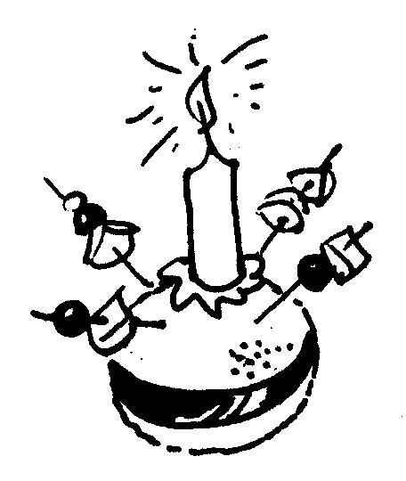

Massingham @ St Mary’s Monday 16th, 1:45pm  
Harpley @ St Lawrence’s Tuesday 17th, 1:45pm   
 with Christingle

**Weds, Dec 18th ~** 9am Holy Communion **at St Botolph’s, Grimston**

**Sunday, Dec 22nd ~** *Advent 4***0830 Holy Communion All Saints’, Roydon   
0930** Lay Led Morning Prayer St Andrew’s**, Little Massingham   
1030** Holy Communion St Nicholas’, Gayton

**Tuesday, December 24th ~** *Christmas Eve***St Mary’s, Great Massingham Christingle 4:30pm  
 Midnight Mass 11:30pm**St Nicholas’, Gayton Family Worship 4pm  
St Botolph’s, Grimston Midnight Mass 11:30pm

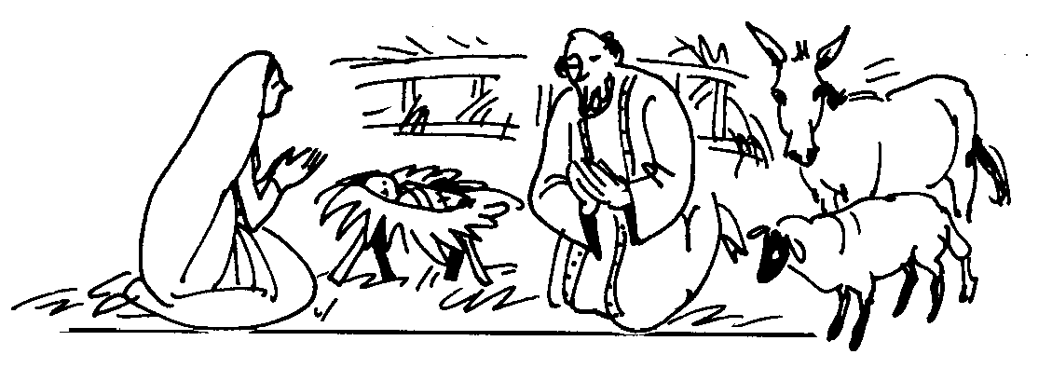

**Wednesday, December 25th ~** *Christmas Day***11am Family Service withNativity St Lawrence’s, Harpley**0830 Holy Communion St Andrew’s, Congham1030 Family Holy Communion St Nicholas’, Gayton

**Sunday, December 29th ~** *Christmas 1***1030**Group Holy Communion St Mary’s, **Great Massingham**

**Thurs, Jan 2nd ~** 9am Holy Communion **at St Lawrence’s, Harpley**

**Sunday, January 5th ~** *Christmas 2*

**0830 Holy Communion** All Saints’, Roydon **0930 Morning Prayer (Lay led)** Saint Andrew’s, Little Mass **\*0930* Family Service (Lay led)** St Lawrence’s**, Harpley**  
**1100** Family Communion St Mary’s, **Great Mass**0830Holy Communion All Saints’, Ashwicken  
1030Holy Communion St Botolph’s, Grimston  
**1030** Morning Praise St Nicholas’, Gayton  
**3pm Prayer Meeting The Rectory, Gayton  
6pm Sung Evensong St Andrew’s, Congham**



The **Bible Study** at this end of the Group will re-start after Christmas:

Instead there will be a meeting for ADVENT:  
Judith will lead ‘Thoughts and Reflections in Advent’

**Thursday, 11th Dec 7pm to 8:30pm; at ‘Cobwebs’ Gt Mass.**

***To make this a time of fellowship please bring a plate of food to share***



**Coffee & Cake** ~ in St Andrews’ Church, **Congham.  
10:30am until noon**; ~ **Saturday, 7th December**  £3 with free refills; proceeds to the church  
 **No meeting in January but back in February 2020!!**



**St Lawrence’s Children’s Workshop**: Friday **20th Dec at 9:30am**  
Birthday Cakes for Jesus ~ come along and ice a cake;

decorate the Christmas Tree and set up the Christmas Crib Scene

All welcome



. ***Come & Sing* with Julian Thomson: Meets fortnightly at 10am on Friday mornings** in St Mary’s, Gt Massingham. This is a good time to get together for a vocal warm-up with a variety of songs: contact Julian on **01485 520721**.

**Sat 14th Dec at 5:30pm in *Fakenham Parish Church*  ~   
 Cantatas & Carols**  ~ a Christmas concert including Bach’s ‘Wachet auf’ (Sleepers awake!). Soloists Angela Brun & Tom Appleton  
Fakenham Choral Society with orchestra directed by Mark Jones  
Tickets **£12** in advance, from 01485 544335then £14 at the door.



**Sat 21st Dec at 4:30pm in *King’s Lynn Minster*** – **King’s Lynn Festival Chorus** presents **~   
 Christmas Fantasia** ~ a concert of festive music and readings with audience carols and mulled wine.  
Tickets from 01553 672416 or 01485 521866 **£12** in advance, then £15 at the door. Free for under 12s; doors open 4pm

As the Reverend Jane’s illness continues please direct all enquiries on church matters (Baptisms, Marriages, Funerals or requests for pastoral visits) to our Team Vicar:   
 The Rev’d Judith Pollard, The Rectory, Grimston **01485**  **601251**

For other information see our website: [www.ggmbenefice.uk](http://www.ggmbenefice.uk)

Please send items for inclusion in the January issue of the ‘Parish Notes’ to the editor by **20th December** ~ Rosemary Mehers [rosemarymehers@hotmail.com](mailto:rosemarymehers@hotmail.com) or Tel: 01485 **521866**